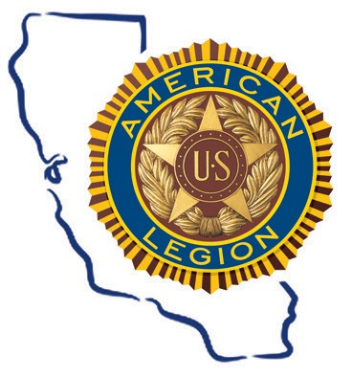2020 American Legion Department of California
Patriotism Purpose
&
Art Contest

The American Legion, Department of California announces the 2020 Patriotism and Purpose Art Contest to honor our Veterans and the sacrifices they have made for our country.
Entry Deadline
September 1, 2020

Who Can Enter
California residents under age 18

Entries
Original unfolded artwork on minimum 8.5” by 11” paper

Prizes
$500 for each of the two age categories (5-12 and 13-17)

How to Enter
Patriotism & Purpose Contest The American Legion, Department of California
1601 7th St, Sanger, CA 93657

The winning artwork will best reflect the impact our Veterans have on our communities and our nation, particularly in inspiring patriotism and love for our country among California’s youth.

The art submission must be produced by the child without assistance from anyone else. The entry must be original and not a copy of another work. Good luck!

For more information, on the contest, please email contest@calegion.org or visit our website at calegion.org

Honoring Our Veterans

CONTEST RULES
- Entry deadline is September 1, 2020. Winners will be notified after judging. Contest winners will be officially announced via the Department website and social media.
- Children who have not turned 18 before September 1, 2020 are eligible.
- The child must produce the artwork without assistance from anyone else. The art submission must be original and not a copy of another work.
- Artwork can be a drawing, painting, collage or other two- dimensional piece. Artwork must be horizontal in layout (also known as landscape), without a matte, frame or border and created on paper no smaller than 8” by 11” and no larger than 18” x 24”.
- Artwork will be judged on its positive representation of military veterans and their impact on children.

SUBMISSION RULES
Artwork and form may be submitted via mail.
- Included with the artwork, but not stapled to the artwork, should be the student first and last name, birth month and birth year, parent name, home address, parent or child email address, and parent phone number.
- The contest may copy and modify any entry for reproduction. Artwork will not be returned and may be used for future contest promotions.
- All entries must be postmarked to the address listed below no later than August 29, 2020.

Patriotism & Purpose Contest The American Legion, Department of California 1601 7th St, Sanger, CA 93657

CONTEST RECOGNITION
One GRAND PRIZE and three HONORABLE MENTION winners are awarded in two categories:
Category A: Artists under the age of 12, as of September 1, 2020 Category B: Artists 13-17, as of September 1, 2020
Honorable Mention winners will receive a framed copy of their artwork and a certificate of recognition. Each winner’s artwork will also be featured in a press release, highlighted on multiple social media sites, and featured on the Department website.

