  - The american Legion
  - Department of california

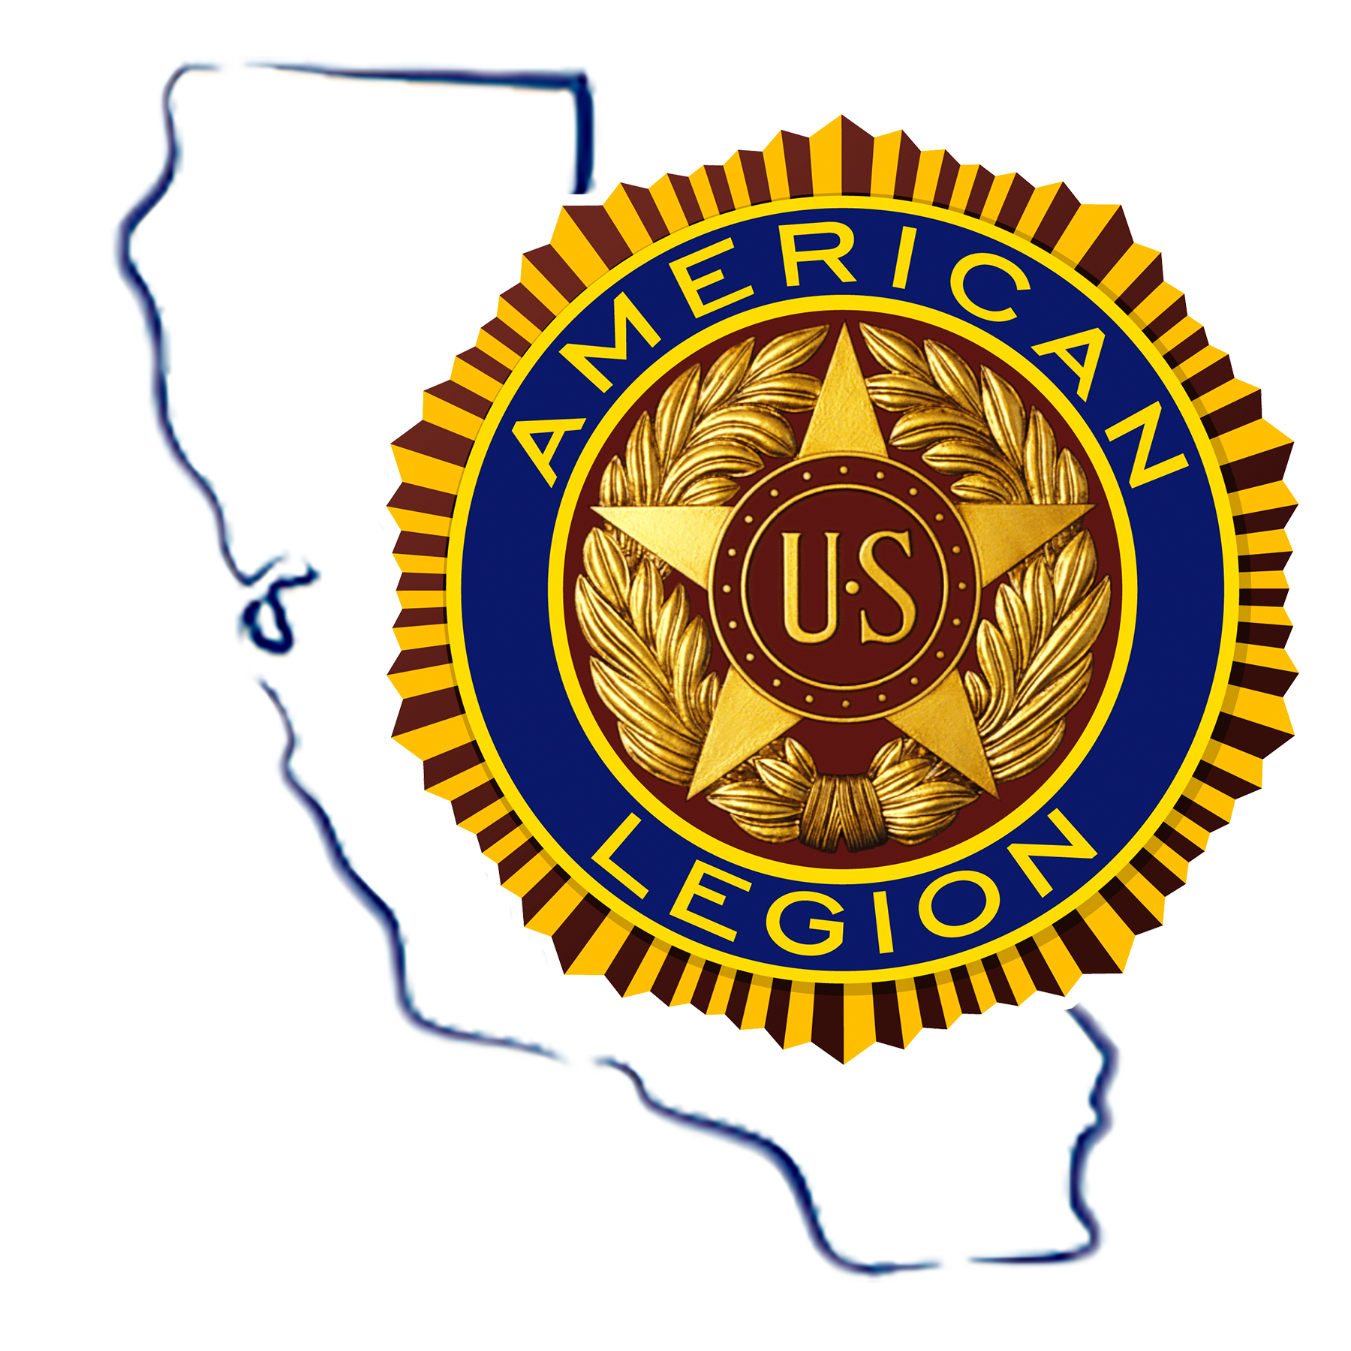

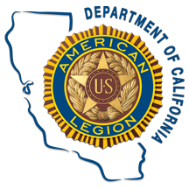

Executive Committee Meeting

March 13-14, 2021

MAKE YOUR RESEVATIONS

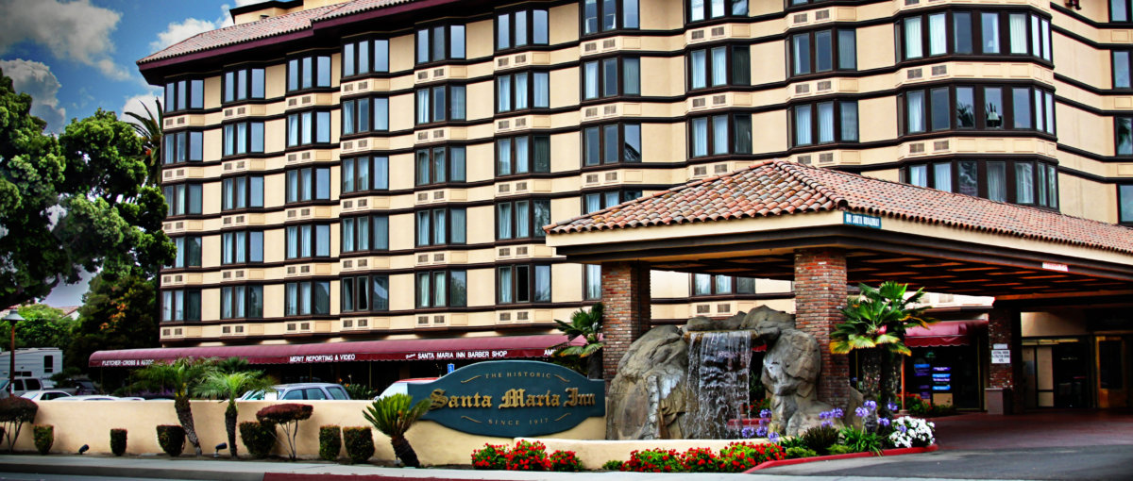

Hotel Location:
Santa Maria Inn
801 S. Broadway
Santa Maria CA 93454

Historic Inn $104.00 + tax
Exec Tower $114.00 +tax
Suites $154.00 + tax

Take Advantage of the Discount Rates Mention:

THE AMERICAN LEGION

DEADLINE: February 12, 2020
(805) 928-0418

Meeting Location:
The American Legion Post 56
501 N Pine Street,
Santa Maria, CA 93458

For Questions Contact:
Veronica Quintanilla
Convention/Meeting Coordinator
(559) 875-8387 or Veronica@caLegion.org

