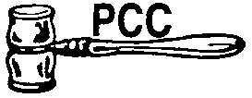
Past Commanders’ Club of California, Inc.
OFFICE | NAME | A.L. Membership # | EMAIL | PHONE
PRESIDENT
1st VICE PRESIDENT
2nd VICE PRESIDENT
SECRETARY
TREASURER
JUDGE ADVOCATE
CHAPLAIN
HISTORIAN
SGT-AT-ARMS
ASST. SGT-AT-ARMS
EXECUTIVE COMMITTEE
EXECUTIVE COMMITTEE
STATE BOARD
CERTIFICATION OF OFFICES 2021 /2022
Outpost No. | District No. | Date of Election: | Date of Installation:

OUTPOST MEETS: LOCATION:
Attest:
Outgoing President Secretary
Updated: 5/2021-mr

