Member Handbook
Your Post Name
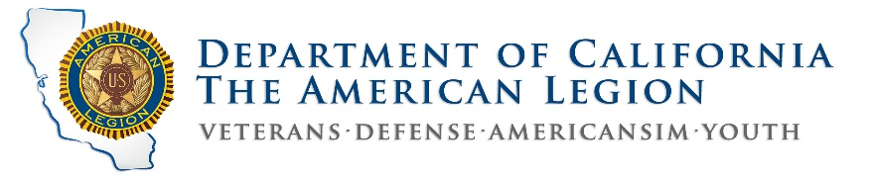

Contents
Our Post 2
Our Post Meetings 2
A Short History 3
Legion Uniform 3
Why wear your Legion Uniform in public? 3
• Volunteers are Super! 4
Our Post Family 5
American Legion Auxiliary (ALA) Unit 5
Our Post Programs 5
Sons of the American Legion (SONS) 5
American Legion Riders (ALR) 5
Training 7
Member Orientation: 7
Basic Training: 7
Publications: 7
Legion College: 7
Post Governance 8
Executive Committee: 8
Vision of Success: 8
Key Goals: 8
Mission Statement: 8
Constitution & By-Laws: 8
Post Leadership 9
Summary Post Leader Duties 9
Post Operating Committees 11
Committee Descriptions 11
No Partisan Politics: 12
Our Post # 12
The Preamble: 13

Our Post
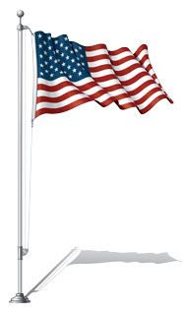
Welcome and Congratulations on your membership in Our Post, in The American Legion. You are now one of the 4.2 million members in our Legion family! We hope your involvement will be a rewarding experience.
Working together, as patriotic Americans our Legion Family, from The American Legion, American Legion Auxiliary, Sons of the American Legion and our American Legion Riders, are all serving America.
The American Legion is the nation’s largest, most influential, effective and dependable veterans service organization. Since our very first meeting in Paris, France in 1919, The American Legion still has a vision for a Strong America which includes four pillars of service: Veteran Affairs & Rehabilitation, National Security, Americanism, and Children & Youth. The American Legion is a powerful force in our nation.
To the extent you are able, we hope you find ways to contribute to the proud future of our Post. Our Post’s future will be defined in our service to our veterans, their families, our local communities, state and our great Nation. The future of our Post will be stronger and more rewarding because of your involvement.
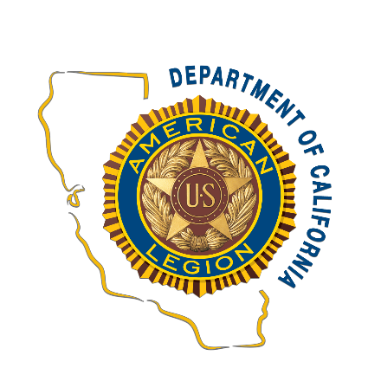
As you become more involved in our Post, you may have questions about our Post. Just bring your questions to a Post officer, we will do our best to help you. We are devoted to “Mutual Helpfulness.”

Our Post Meetings
Business Meeting: First Wednesday @ 7 p.m.
Member Meeting: Second Wednesday @ 7 p.m.
Social: Every Monday @ 5 p.m. (Except 3-day weekends.)

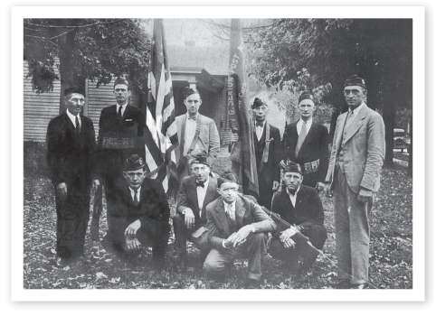
A Short History
Our Post in Hometown, USA was chartered by The American Legion on September 26, 1919, with 43 members. The first meeting was held on Thursday October 2, 1919 at the Old Hometown Hall. The original 1919 charter of our Post is framed and hangs on the wall in our Legion clubhouse, it lists the names of our charter members.
Our Post is over 300 members strong and growing. Our Post is an integral part of the greater Hometown community and a proud advocate for veterans on the local, state, and national level. Our local membership extends throughout the county.
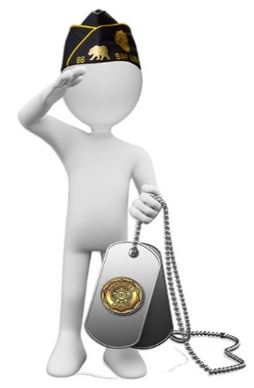
Legion Uniform What is the official uniform of The American Legion? "A Legionnaire is in uniform if wearing an official American Legion Cap."
Why wear your Legion Uniform in public? Legionnaires like us, seen in uniform doing the good work of The American Legion creates a positive image. This helps our community "see" The American Legion as an organization they want to support. It is a very important element of our public relations and marketing efforts.
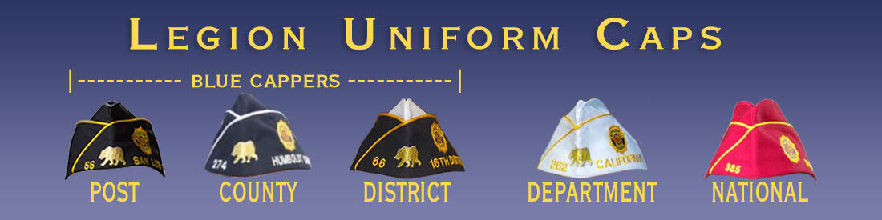
There is no benefit to Legionnaires being invisible to the public as we do the good work of the Legion, so please expose yourself to the community as proud members of The American Legion, wear your uniform cap.
Legion Language and Protocols
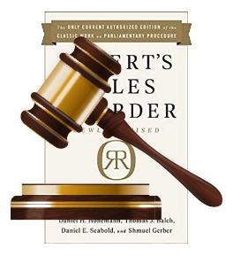
New Legionnaires often find the following information helpful:
- Meeting Conduct. Robert’s Rules of Order, Newly Revised, governs the conduct of Post meetings
- Ceremony Dignity. The ceremonial services of The American Legion are conducted with the solemnity befitting the dignity of this organization.
- Gavel. A chair’s gavel is a symbol of authority & ensures orderly meetings.
- One tap is a message to the members to be seated following the opening ceremony, the completion of a business item, or follows the announcement of adjournment.
- Two taps of the gavel call the meeting to order.
- Three taps of the gavel are the signal for members to stand in unison on the third tap.
- A series of sharp taps is used to restore order at a meeting.
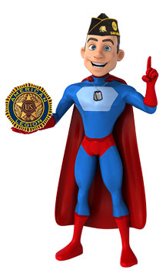
- Silent Tribute. Legionnaires standing in silent tribute
in memory of departed comrades during meetings or ceremonies will face the U.S. Flag with Legion cap or handheld over their heart.
- Addressing Officers. In addressing an officer of The American Legion, use the title of the officer and then his/her name.
- The Hand Clap. This long held Legion tradition is a slow and rhythmic clapping of hands of standing Legionnaires, much like the slow beat of a drum. The hand clap is used to welcome new members and guests when they are brought forward to be introduced and when leaving the lectern.
- Volunteers are Super!
Your Volunteer Time Has Value: Volunteer time is now estimated to be worth over $24 per hour!
Legionnaire volunteer time is even more valuable. We are a Legion of super volunteers!

Our Post Family
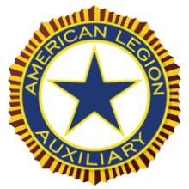
Our Post, as the parent organization, has three other important units in our local Legion family. They are:

American Legion Auxiliary (ALA) Unit
Founded in 1919, the American Legion Auxiliary is the oldest member of the Legion Family of units and the most independent.
The Auxiliary is a separate organization with their own legal and
corporate identity.
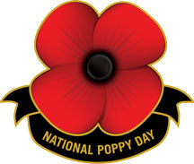
Every Spring the Auxiliary promotes the red poppy as a symbol of the sacrifices our military have made, a symbol to open people’s hearts and inspire them to donate to this important fundraising program.
Meeting: First Wednesday @ 5 p.m.

Our Post Programs
Our post offers many outstanding programs that serve our community, veterans and youth.
The Sons of the American Legion and American Legion Riders are both important programs in our Post.

Sons of the American Legion (SONS)
Founded in 1932, Sons of The American Legion (SONS) squadron consists of boys and men of all ages whose grandparents or parents served in the U.S. Armed Forces.
Meeting: First Monday @ 6 p. m.

American Legion Riders (ALR)
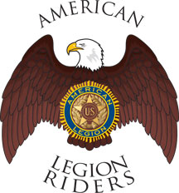
The American Legion Riders (ALR) are Legionnaires, who are
also motorcycle enthusiasts. They all belong to the Legion, the Legion Auxiliary or the Sons of the American Legion. Legion Riders are well known for their charitable work.
Meeting: First Wednesday @ 5:30 p.m.

Training
Effective training is important to the success of our Legion.
Quality training improves our ability to succeed by improving member involvement and operational performance. Training
also helps teach organizational values and identify future post leaders. Conversely, the lack of effective training can lead to losing our focus on success and can limit our operational performance.
Many who accept leadership roles in The American Legion are self-motivated by a desire to serve others and seek out training because they want to become stronger, better-informed leaders.
Member Orientation: Review of this Member Handbook with new members is a good introduction to The American Legion that will help many Legionnaires better understand the good work our Legion does for our veterans, their families and our community
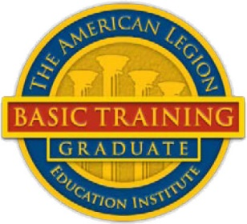
Basic Training: The American Legion's official training program for officers, members, Legion College applicants and those who simply want to expand their knowledge of the nation's largest veterans service organization. (https://www.legion.org/alei)
Publications: The American Legion publications can be an excellent training resource for those who are self-motivated. (https://www.legion.org/publications)
Legion College: There two versions of The American Legion College that California Legion Family members can attend. The California American Legion College is conducted in California and staffed by a well-qualified and enthusiastic staff from throughout California. The National American Legion College is held annually in Indianapolis, Indiana.
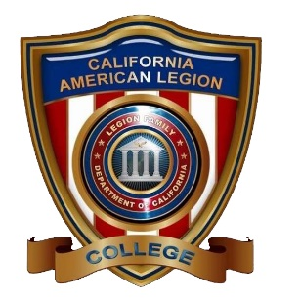
The mission of The American Legion College is to teach the values of The American Legion; develop leaders within The American Legion Family; and encourage new ideas to help move the Department forward in the future. The curriculum centers on instruction by facilitators, comprised of graduates of the National American Legion College and other qualified instructors from the department and national.

Post Governance
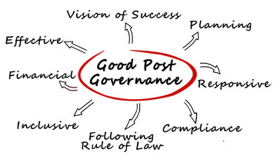
Our Post By-Laws state, “The administration, governance and management of this Post is entrusted to the Executive Committee.” Good post governance is an essential duty of post leaders and it includes a variety of elements. It is realized in our long-term post success.
Executive Committee:
The Executive Committee members are: Commander, First Vice Commander, Second Vice Commander, Adjutant, Finance Officer and Executive Committee Members-at-large. The Executive Committee Members-at-large (Elected - The number of Executive Committee Members-at-large, vary by post.) are advocates for the general membership, assist officers in directing post business, and act as post representatives in the absence of post officers.
Vision of Success:
“Our Post excels in service to fellow veterans, their families, and our community, while consistently operating as a model of quality post operations."

Key Goals:
- Sustained membership growth
- Financial solvency and stability
- Excellent leadership development
- Successful programs, and
- Quality service to veterans, their families and community
Mission Statement:
“Our Post exists to support fellow veterans, their families, and our community.”
Constitution & By-Laws:
The Constitution & By-Laws are two of the most important documents in our post operation. They define the complete responsibilities of all Post officers and they are available from the post Adjutant.

Post Leadership
Post Leadership in The American Legion and in our Post is provided by Legionnaires, like you, who volunteer to serve. Post leaders are fundamentally responsible for the success of our Post. They serve in many different leadership roles as committee members, chairmen and Post officers. Our Post leaders provide honorable and noteworthy service to our veterans, their families and the communities we serve.
Many believe leadership is not something you are born with and it cannot be awarded or appointed. True leadership for many, is something learned and earned through the hard work of service to others. Well-developed leadership skills are key tools in developing good leaders. Legion leaders must have stellar character and transparent integrity.
In addition to being committed to the success of our post, leaders must give an adequate commitment of time, sufficient personal energy and must communicate effectively, to give our posts strong roots in the communities where we serve our veterans.

Summary Post Leader Duties
Our Post Constitution and By-Laws are the ultimate reference on the duties of our post leader. The following descriptions are intended as a generic overview of what many consider key responsibilities of post leaders.
The post Commander, Finance Officer and Adjutant, are “required” officers in the annual Certification of Eligibility of American Legion Post Officers. This is one of the mandatory reports we must submit annually, to maintain our charter.
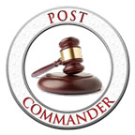
Post Commander (Elected) "First among equals." is a good way to look at the relationship of the Post Commander to other post members. The Commander ensures the post's vision of success is completed and keeps the post family together in the process. The Post Commander traditionally serves as the President of the Board of Directors for incorporated posts. The Post Commander is also the voice of the post, within the post and at meetings beyond the post. Post Commanders also work with and through other leaders to complete the post business, as they cultivate and guide them for future leadership roles.
Finance Officer (Elected) Much of the Post Finance Officer's work is defined and determined by standard accounting practices and the needs of the post. The Post Finance Officer is the person of integrity that helps develop a post budget and administers the post book of accounts. Finance Officers also advise post leaders on the formulating and administering of financial policies, including the annual Post budget.
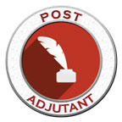
Adjutant (Elected) Whether seen as a Post ‘First Sergeant’ or a Continuity Officer, the Adjutant’s role is critical in the long-term success of our post. Adjutants are responsible for keeping official records of our post business, minutes of meetings and many key administrative compliance duties.
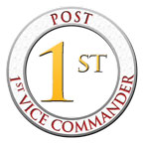
First Vice-Commander (Elected) The American Legion "Officer's Guide" states this about the First Vice Commander, "In the majority of posts, a first and second vice commander are elected, with membership the primary concern of the first vice commander." In too many posts, the First Vice Commander serves as a Membership Committee of one. A post, even a small post, should have a true Membership Committee to help with recruitment, transfers from administrative posts, member renewals, member retention and with ensuring the post routinely has personal (by phone or in person) contact, with every member of the post. A Membership Committee of two (or more), is far more effective than the committee of just one.
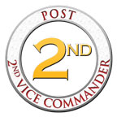
Second Vice-Commander (Elected) In our Post the Second Vice Commander is the designated liaison to other veteran organizations, coordinates new member orientation and shall oversee Post morale to include entertainment and special programs, and other duties as directed by the Post.
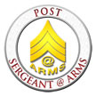
Sgt-at-Arms (Appointed) shall preserve order at all meetings, ensures members are properly greeted at the door, makes new members welcome, and oversees flag etiquette/disposal, and shall perform such other duties as may be assigned to him by the Post. This office is commonly the first of four steps to becoming Post Commander.

Post Operating Committees
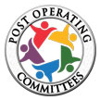
Through work on committees, our members provide the hard work needed for our post’s success as they plan, organize, communicate and implement our post programs.
The Post Operating Committees are critical to increasing active membership. Committees within our Post create a forum for members to pursue personal interests. They allow for the strengths and dedication of our members to shine. Post members, like you, serving on committees can grow as productive post members and leaders. Committee work also functions as a very important training ground to develop the leadership skills and knowledge of the Legion, that future Post leaders will need to succeed.
To help advise the Commander and Executive Committee the Post may establish and define the work of Post committees. With the consent of the Commander, each committee chairperson selects at least two other members to serve on each committee and they will serve for an indefinite term at the discretion of the chairperson.

Committee Descriptions
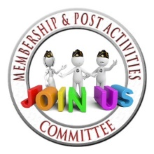
Membership Committee - has charge of all matters pertaining to membership eligibility, growth, acceptance, retention, and renewals. Guidance is provided by the First Vice Commander.
Executive Committee - the administration, governance and management of our Post is entrusted to the Executive Committee. The number of Executive Committee Members-at-large, vary from post to post. They are often seen as advocates for the general membership, assist post officers in directing post business, and act as post representatives in the absence of post officers.
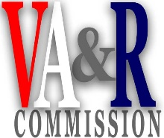
Veterans Affairs & Rehabilitation (VA&R) Committee - is responsible for bringing to the attention of members and their dependents the rights and benefits granted them by law. They shall assist veterans in the pursuance of claims and in obtaining other veteran’s rights and benefits; to visit comrades who are sick or disabled; to visit and comfort members of their families when sick or bereaved.

Finance and Ways & Means Committees - work together to supervise the financial duties of the Post, prepare the annual budget and advise the Executive Committee on financial matters. They also develop fund-raising projects. Once approved they are responsible for the project’s completion and success.
Our Annual Pancake Breakfast is our primary fundraiser that supports our youth and community programs. Through the dedicated support of our Legion Family and the friends of our Post, this is our most important fundraising event.
Public Relations (PR) Committee – promotes Post programs and social activities to members and local community. Also, responsible for post newsletter, fliers and all Post online communication tools
Facilities Committee - Handles Post operations and maintenance of facilities.
No Partisan Politics: According to Article II, Section 2, of the Constitution of The American Legion, “The American Legion shall be absolutely nonpolitical and shall not be used for the dissemination of partisan principles nor for the promotion of the candidacy of any person seeking public office or preferment.”
The National Charter, approved by Congress, also stipulates The American Legion as an organization is nonpolitical* which has been interpreted by the National Judge Advocate as “nonpartisan” in modern lingo. Therefore, The American Legion as an organization is prohibited from contributing, helping or endorsing a candidate. However, a member, as a private citizen, and not representing the organization, can employ whatever legal and ethical means to advance his or her candidate.

Our Post #
1601 7th. Street, Sanger, CA 93657 XXX-XXXX-XX
Email: mail@ourpost.org Website: http://ourpost.org

The Preamble:
For God and Country, we associate ourselves together for the following purposes:
To uphold and defend the Constitution of the United States of America;
To maintain law and order;
To foster and perpetuate a one hundred percent Americanism;
To preserve the memories and incidents of our associations in all wars;
To inculcate a sense of individual obligation to the community, state and nation;
To combat the autocracy of both the classes and the masses;
To make right the master of might;
To promote peace and goodwill on earth;
To safeguard and transmit to posterity the principles of justice, freedom and democracy;
To consecrate and sanctify our comradeship by our devotion to mutual helpfulness.
The Preamble is printed on the back of your membership card.

Our Post’s Handbook was designed and produced by
Rick Pushies, Webmaster Post 66
If you have questions or need assistance adapting this document for you post’s use, contact him at:
webteam@calegion.org or 805-925-9144

