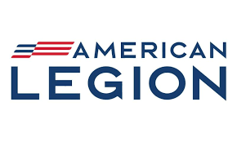

Americanism Commission
The meeting was held on Saturday August 23, 2023, at the National Convention
We started on time at 8:30 am. It was short and sweet with a guest speaker Brig Gen Regina Aye. She spoke about Civil Air Patrol. She gave the basics of the program. The core values are integrity, service, excellence, and respect. She said they are teaching leadership skills, fitness, character building and career experience in Aerospace. The meeting when on with the second speaker Barbara Haramis Executive Director Childhood Leukemia Foundation. She spoke about the childhood grant Program. They both received awards and at this point the meeting was recess.

Jr Duarte

