Department Resolution No. 2026 - 002
Subject: Formal Apology to the Families of Johnny Ritchey and Nelson Manuel for 1940 American Legion Baseball Discrimination
Origin: American Legion Post 6 (San Diego, CA), District 22, Department of California
Submitted By: (Submitting Post member)

RESOLUTION

WHEREAS; In 1940, during the American Legion Baseball “Little World Series” in Albemarle, North Carolina, two San Diego Post 6 players, Johnny Ritchey and Nelson Manuel, were barred from competition solely because of their race; and

WHEREAS; Two years earlier, in 1938, San Diego Post 6 had won the national championship but was prohibited from playing its Black players in the tournament, after which Coach Mike Morrow was assured that such discrimination would not occur again; and

WHEREAS; When Post 6 returned to the national stage in 1940, the team competed successfully in Shelby, North Carolina, where Ritchey and Manuel were permitted to play against St. Louis Aubuchon Post 186, but upon arriving in Albemarle for the championship game, a telegram from Mr. Homer Chaillaux, Chairman of The American Legion’s Americanism Committee, stated, “Negroes Nelson Manuel and John Ritchey will not play in the opener today nor are they allowed to play for the remainder of the series,” thus forbidding them from participation; and
WHEREAS; This action was an injustice that violated the principles of fair play, equality, and Americanism upon which The American Legion was founded; and
WHEREAS; Despite this exclusion, Johnny Ritchey and Nelson Manuel persevered and later broke the color barrier in professional baseball on the West Coast by joining the San Diego Padres, helping to pave the way for future generations of minority athletes and advancing the cause of racial equality in American sports; and

WHEREAS; 2025 marks the 85th anniversary of this event and acknowledging this past wrong and honoring these men’s courage would demonstrate The American Legion’s continued commitment to the values of fairness, integrity, and equal opportunity for all who serve and participate in its programs, therefore, be it

RESOLVED; By The American Legion at the Department Executive Committee meeting in Vacaville, California, on March 13-15, 2026, that The American Legion formally acknowledge and apologize in writing to the families of Johnny Ritchey and Nelson Manuel for the organization’s decision in 1940 to bar them from competition because of their race.

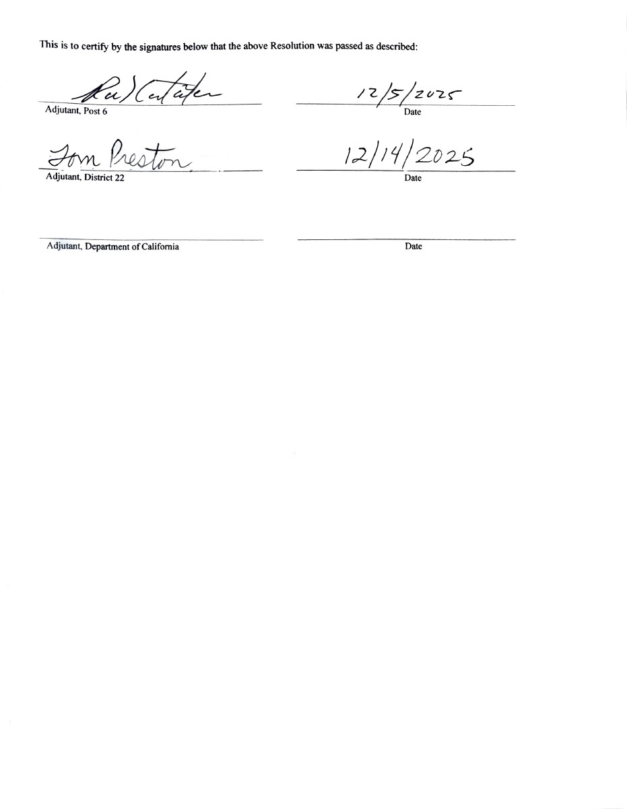

FACT SHEET

Purpose:

This fact sheet summarizes the historical injustice involving American Legion Post 6’s 1940 baseball team, the current request for a formal written apology from The American Legion National Headquarters, and related public endorsements and historical records.

Historical Context:

YEAR EVENT/DETAIL
1938 - San Diego, CA | San Diego Post 6, which included two Black players — Johnny Ritchey and Nelson Manuel — qualified for the American Legion national baseball tournament but was prohibited from allowing those players to compete because of racial exclusion.
1940 - Shelby, NC | Post 6 again reached the national finals. Ritchey and Manuel were permitted to play in the early rounds in Shelby, North Carolina, where Post 6 defeated St. Louis Aubuchon Post 186.
1940 - Albemarle, NC | Albemarle, North Carolina (Finals) - On arrival for the championship series, Post 6 received a telegram from Homer Chaillaux, Chairman of The American Legion’s Americanism Committee, stating: “Negroes Nelson Manuel and John Ritchey will not play in the opener today. Nor are they allowed to play for the remainder of the series.” Both players were forced to sit out the finals due to their race.
1948 - San Diego, CA | Despite this discrimination, Johnny Ritchey and Nelson Manuel continued to play baseball. In 1948, Ritchey broke the Pacific Coast League color barrier as a member of the San Diego Padres — becoming the first Black player to take the field in organized professional baseball on the West Coast. Ritchey was inducted into the San Diego Hall of Champions Breitbard Hall of Fame in 2017. His bronze bust is displayed at Petco Park in San Diego.
Sources: Society for American Baseball Research (SABR), San Diego Union-Tribune Archives, and American Legion historical archives.

The Union-Tribune Article and Renewed Awareness:
An article published by the San Diego Union-Tribune on August 28, 2025 with this being the 85th Anniversary of the event, revisited the story of Post 6 and recognized it as a pivotal moment in “breaking the color barrier below the Mason-Dixon Line” in Shelby, North Carolina. This coverage sparked national interest and renewed attention to the lack of an official apology by The American Legion. To date, no apology has ever been issued to the families of Johnny Ritchey or Nelson Manuel.

Public Endorsement:

Ms. Samantha Lisk Carson
Granddaughter of J.W. Lisk
North Carolina

On September 25, 2025, Samantha Lisk Carson, granddaughter of J.W. “Lefty” Lisk, the star pitcher for Albemarle Post 76 (the opposing team in 1940), contacted District Commander Vic Martin after reading about the incident in the Union Tribune. In her message, she wrote:
“I was appalled to learn of the discrimination experienced by Johnny Ritchey and Nelson Manuel. I grew up in Albemarle, as did my father (Lefty’s son), and I still live in NC. I never knew about the harassment or discrimination those men faced; it was never mentioned, although the championship itself was talked about… Do you know whether the American Legion ever issued an apology to those men or their families? It certainly should!”

In a follow-up exchange, Samantha added:
“Thank you for sending this article (by Albemarle native Perry Eury). As Lefty’s granddaughter, I can confirm that was his nickname until he passed away in 2007… It was a terrible act of discrimination, unsportsmanlike and just plain wrong, and I’m sorry for it.”

She also shared a note from her uncle, John Lisk, who reflected on how the story was suppressed for decades:
“I wasn’t aware of the situation until I was in high school… Neither of your grandparents nor any of your other relatives ever said anything about it. It was a very different time… I can tell you that unlike many people of that era, your grandparents never encouraged us to think of ourselves as better than anyone else or superior to anyone else.”

A Symbolic Act of Reconciliation:

Following a personal conversation between Samantha Lisk Carson and District Commander Vic Martin, a symbolic proposal emerged for April 15, 2026 (Jackie Robinson Day):

Bring Samantha Lisk Carson to San Diego to throw the ceremonial first pitch, with Johnny Ritchey’s granddaughter, Carlee Battle, catching behind the plate at Petco Park.

Both women played high school softball — a fitting tribute to their grandfathers.
This act would embody Dr. Martin Luther King Jr.’s vision that “one day… little black boys and black girls will be able to join hands with little white boys and white girls as sisters and brothers.”
Two granddaughters - one white, one Black - symbolically playing catch to close a historic circle.

Why This Matters:

- The exclusion of Ritchey and Manuel in 1940 violated The American Legion’s core values of fair play, equality, and Americanism.
- Acknowledging this injustice strengthens the Legion’s moral leadership and demonstrates its continued commitment to honesty, compassion, and integrity.
- An official apology would honor the men, their families, and the modern legacy of inclusion that defines today’s American Legion Baseball program.

Current Action and Request:

- This resolution originated at Post 6, The American Legion, Department of California, and calls for a formal written apology from The American Legion National Headquarters to the families of Johnny Ritchey and Nelson Manuel.
- Upon adoption by Post 6, it will advance to District 22, then to the Department of California, and finally to National Headquarters for consideration and action.

Additional Notes:

- American Legion Baseball, founded in 1925, remains one of the nation’s premier youth programs promoting leadership, teamwork, and citizenship.
- The 1940 Albemarle incident stands as a rare, documented case of racial exclusion within the Legion Baseball program.
- The 85th anniversary has reignited calls for accountability and reflection, aligning with the Legion’s broader commitment to diversity and inclusion.

References and Further Reading:

- Society for American Baseball Research (SABR):
“San Diego Breaks Pacific Coast League Color Barrier”
- SABR Biography: Johnny Ritchey
- San Diego Union-Tribune, August 28, 2025 – coverage of 85th Anniversary.
- American Legion Archives – “Americanism Committee Correspondence, 1940.”

Point of Contact:

Tom Preston
Commander, American Legion, Post 6 – San Diego
Victor Martin
Commander, American Legion, District 22 (San Diego County)
mn.vicmartin@gmail.com

